**Industrial Project Report**

*Submitted in partial fulfillment of the degree of*

**Btech in Electrical Engineering**

**By**

**ARJUN SINGH [11901620001]**

**SONAM DARGEY BHUTIA [11901620003]**

**SANDIPAN BASU [11901620005]**

**Third-year student of**

**SILIGURI INSTITUTE OF TECHNOLOGY**

*THIS IS SUBMITTED IN FULFILLMENT OF THE REQUIREMENTS FOR THE DEGREE OF*

**AFFILIATED TO**

**Maulana Abul Kalam Azad University of Technology**

**Under the supervision of**

Mr. Ripam Kundu

**Sikharthy Infotech Pvt. Ltd.**

***GOOGLE SEARCH ANALYSIS USING PYTHON***

By

ARJUN SINGH [11901620001]

SONAM DARGEY BHUTIA [11901620003]

SANDIPAN BASU [11901620005]

UNDER THE GUIDANCE OF

**Mr. Ripam Kundu**

**Project Guide**

**Sikharthy Infotech Pvt. Ltd.**

*THIS IS SUBMITTED IN FULFILLMENT OF THE REQUIREMENTS FOR THE DEGREE OF*

**B.Tech**

IN

Electrical Engineering

**SILIGURI INSTITUTE OF TECHNOLOGY**

**AFFILIATED TO**

**Maulana Abul Kalam Azad University of Technology**

**Department of Electrical Engineering**

I hereby forward the documentation prepared under my supervision by **Ripam Kundu Sir** entitled **Siliguri Institute Of Technology** to be accepted as fulfillment of the requirement for the Degree of Bachelor of Technology in Electrical Engineering, **Siliguri Institute Of Technology** affiliated to **Maulana Abul Kalam Azad University of Technology** (**MAKAUT**).

|  |  |
| --- | --- |
| ____________________________________________________  **Mr.Ripam Kundu**  **(Software Developer)**  **Project Guide**  **Sikharthy Infotech Pvt. Ltd.**  **Shilpi Ghosal**  **(Director)**  **Sikharthy Infotech Pvt. Ltd.** | ____________________________________________________  **HOD**  **Department Of Electrical Engineering, SIT** |

**TPO**

**Siliguri Institute of Technology**

**Certificate of Approval**

The foregoing project is hereby approved as a creditable study for the B.Tech in Electrical Engineering presented in a manner of satisfactory to warrant its acceptance as a prerequisite to the degree for which it has been submitted. It is understood that by this approval the undersigned do not necessarily endorsed or approved any statement made, opinion expressed or conclusion therein but approve this project only for the purpose for which it is submitted.

Final Examination for

Evaluation of the Project ----------------------------------------

-----------------------------------------

------------------------------------------

**Signatures of Examiners**

**ABSTRACT**

*The purpose of this project is to help business to perform google search*

*analysis, to understand what people are looking for on google at any*

*given time and to strategize their marketing policy as well as their*

*business and for general knowledge preferences, for other such purposes*

*like flight info has also been added to explain the framework of search*

*analysis.*

*Here a list of Dataset of CSV(‘Comma separated value’)file has been used*

*for the search analysis of flight info and for google search analysis a*

*special API library package known as Pytrends has been used to*

*generate dataset in real time from the recent trend of search in google*

*search engine.*

**ACKNOWLEDGEMENT**

It is a great pleasure for me to acknowledge the assistance and participation of a large number of individuals in this attempt. Our project report has been structured under the valued suggestion, support, and guidance of **Mr. Ripam Kundu**. Under his guidance, we have accomplished the challenging task in a very short time.

Finally, we express our sincere thankfulness to our family members for inspiring me all throughout and always encouraging us.

**TABLE OF CONTENTS**

Chapter 1: Introduction

1: Introduction

Chapter 2: What We Used

2.1: Python

2.2: Pytrends

Chapter 3: Functionality

3.1: Working Principle

Chapter 4: Functional Requirement of the System

4.1: Software Requirement

4.2: Functional Requirements

Chapter 5: Code and Snapshots

5.1: Codes

5.2: Snapshots

Chapter 6: Conclusion

Chapter 7: References

**INTRODUCTION**

*It is of profound significance to analyze, huge heap of data to understand the trends and act on it to improve or to make better future decisions, therefore this is the reason we have this project to help business to perform google search analysis, to understand what people are looking for on google at any given time and to strategize their marketing policy as well as their business and for general knowledge preferences, for other such purposes like flight info has also been added to explain the framework of search analysis.*

**WHAT WE USED**

1. **Python: -**

**P**ython is a popular programming language. It was created by Guido van Rossum, and released in 1991.

It is used for:

* web development (server-side),
* software development,
* mathematics,
* system scripting.

1. **Pytrends:**

Pytrends is a Google trends API used in python. It helps to analyze and list out the most popular Google search results on a specific topic or a subject, based on different regions and languages.

**FUNCTIONALITY**

**WORKING PRINCIPLE:**

* *First we have to choose the option between Flight booking details and Google search trends*
* *When the search term is entered then the whole details of the searched items is provided to the output.*
* *We have used pandas, matplotlib libraries, etc.*
* *We have used Pytrends for collecting the data from the google trends*
* *This program will give the latest trending searches, most searched topic in a particular year, etc*
* *For getting flight booking details the program will fetch the data from the CSV file which stores all the data for flight booking.*

**FUNCTIONAL REQUIREMENTS OF THE SYSTEM**

***SOFTWARE Requirements:***

* *OS Microsoft*
* Windows OS 11
* Visual Studio Code

***Functional requirements:***

* Python programming language
* Library package – matplotlib, pytrend and pandas

**CODE AND SNAPSHOTS**

Code🡪

Snapshots-🡪

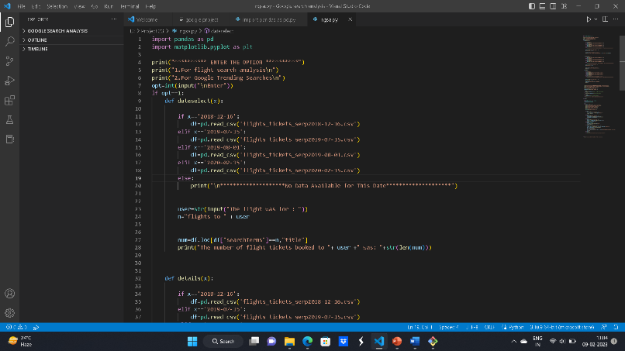

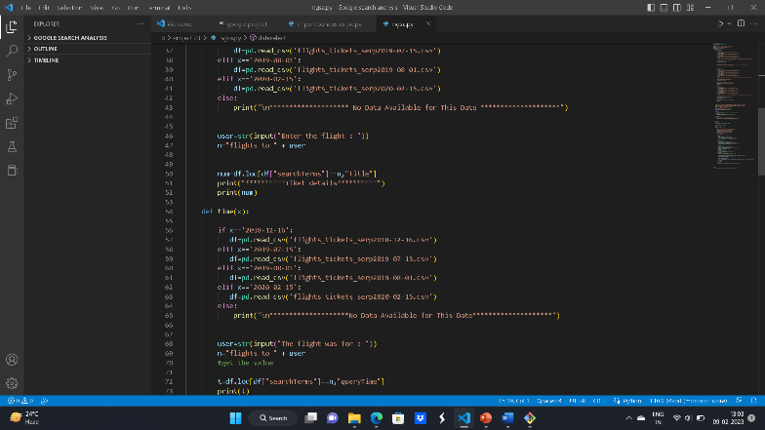

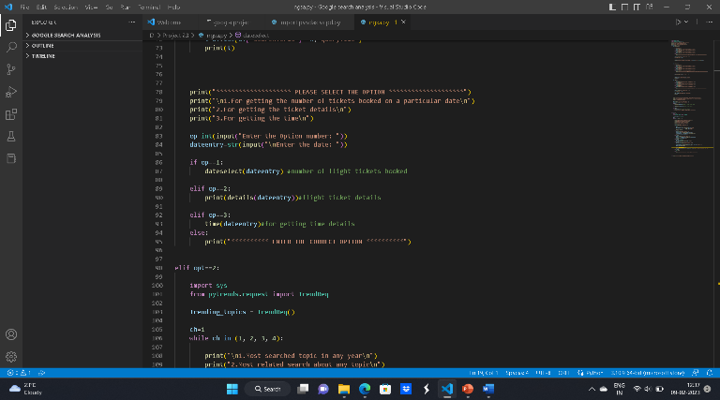

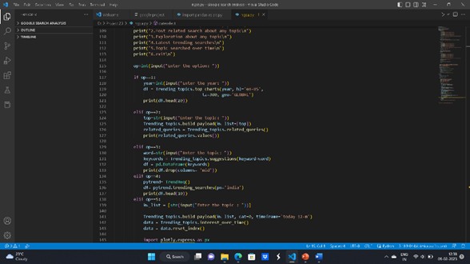

Contribution

Arjun Singh and Sonam Dargey Bhutia- Coding and PPT.

Sandipan Basu – Project Report.

Conclusion

*It is of profound significance to analyze, huge heap of data to understand the trends and act on it to improve or to make better future decisions, therefore this is the reason we have this project to help business to perform google search analysis, to understand what people are looking for on google at any given time and to strategize their marketing policy as well as their business and for general knowledge preferences, for other such purposes like flight info has also been added to explain the framework of search analysis.*